**Phase 5 Project 4**

**Deploy Docker Swarm:**

Creating a instance in aws which is swarm master, swarm worker1 and swarm worker 2

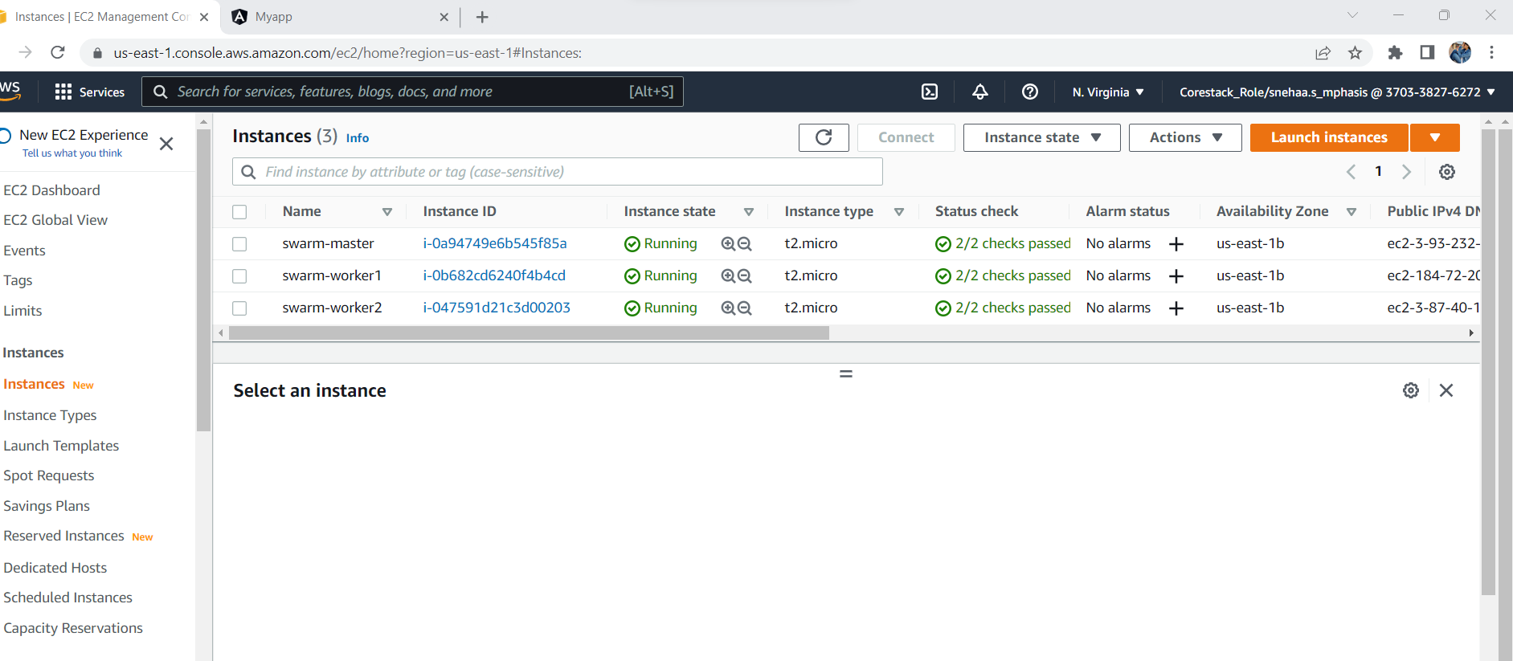

Setting the inbound rules of swarm master as all target group id and source as launch wizard-1.

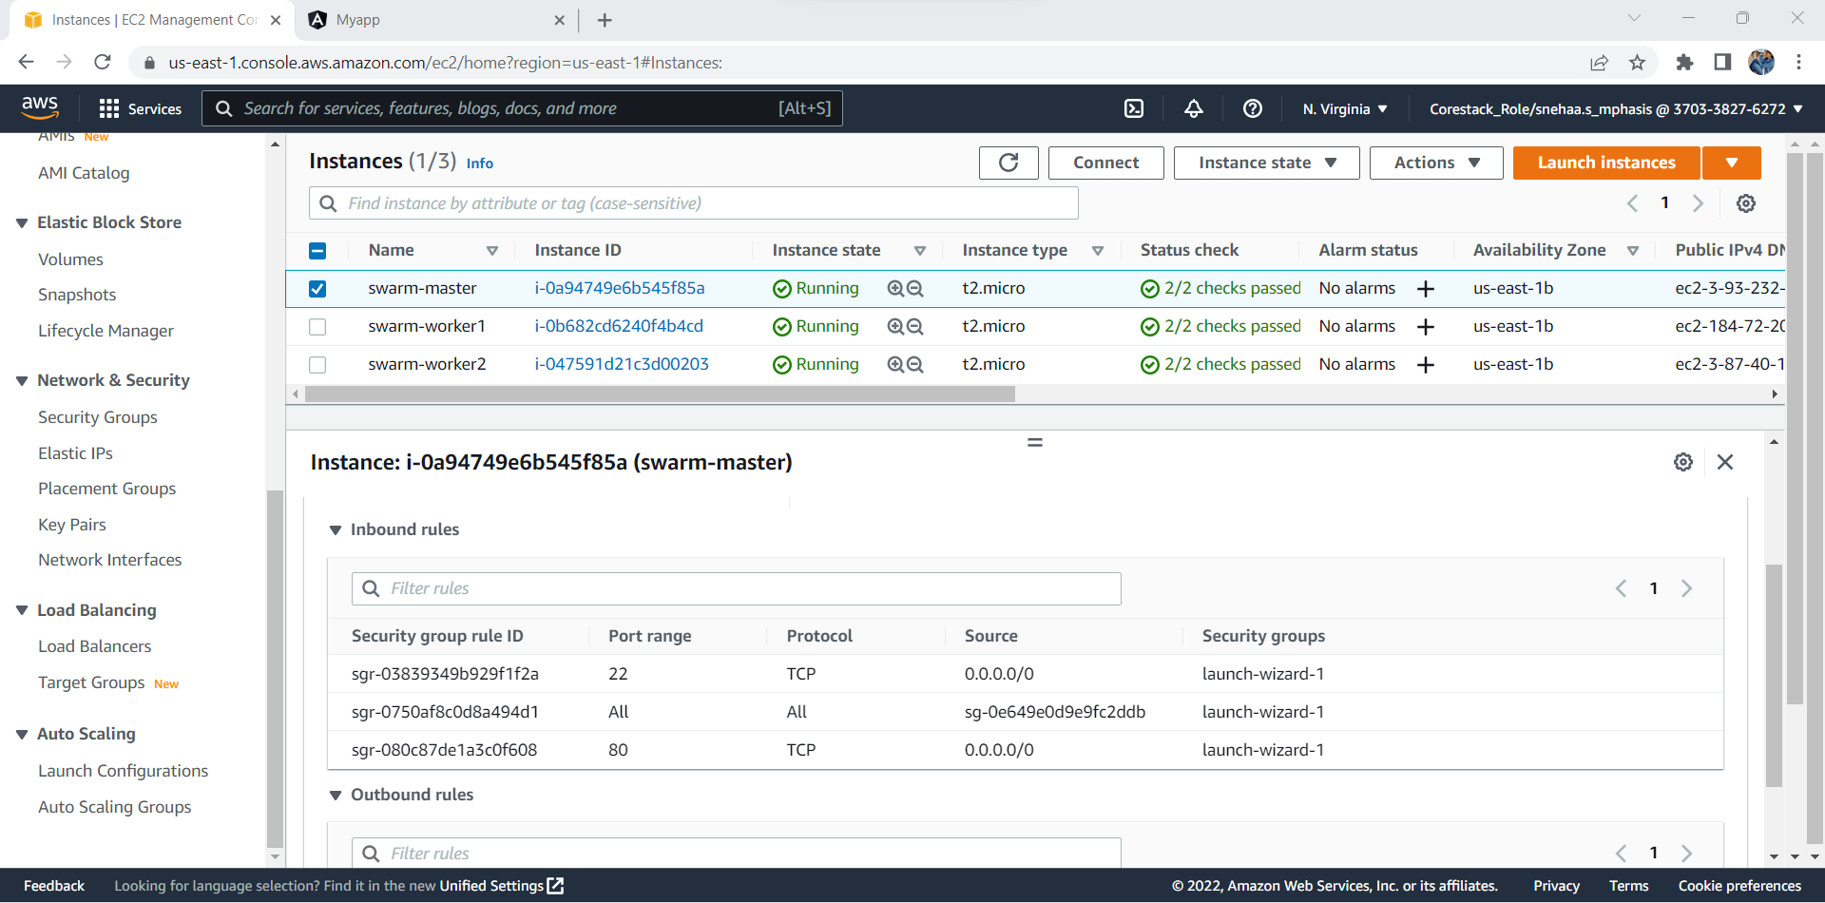

Installing putty where ec2-user with public id for ur respective instance of master,worker1 and worker2 . setting up the SSH <AUTH> where keypair created with private key file is attached and accepted.

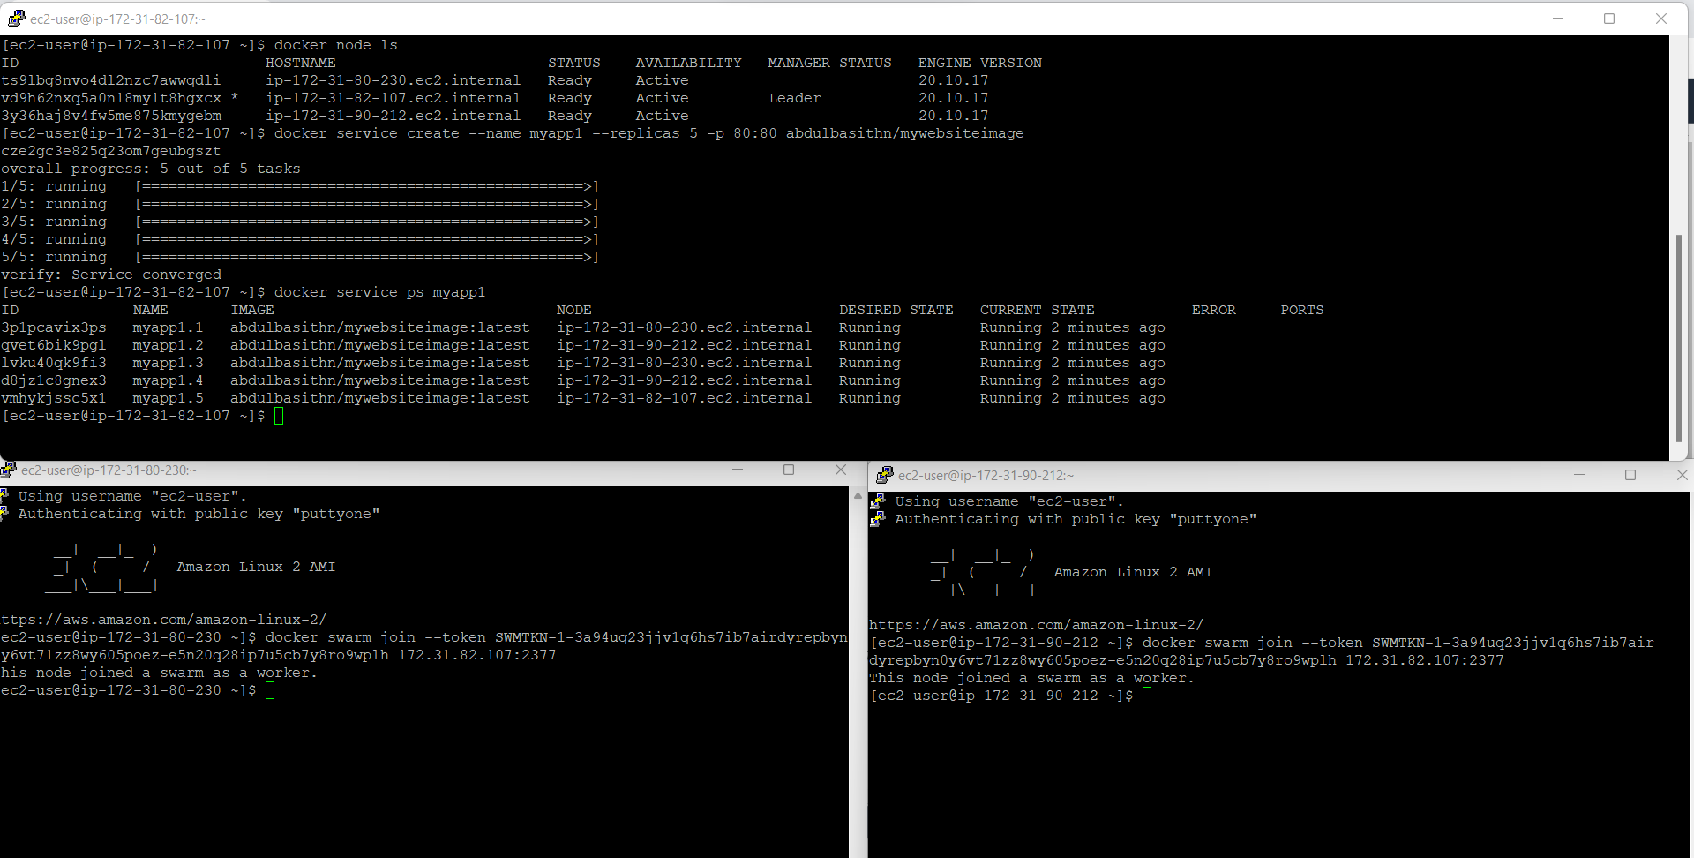

Output is shown where ip address of worker1 is shown

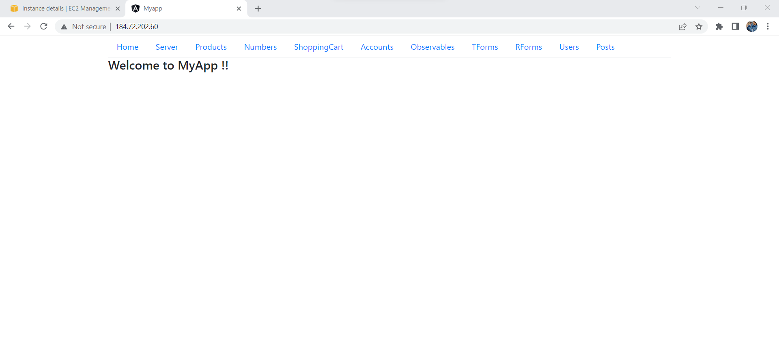

Output is shown where ip address of worker2 is shown

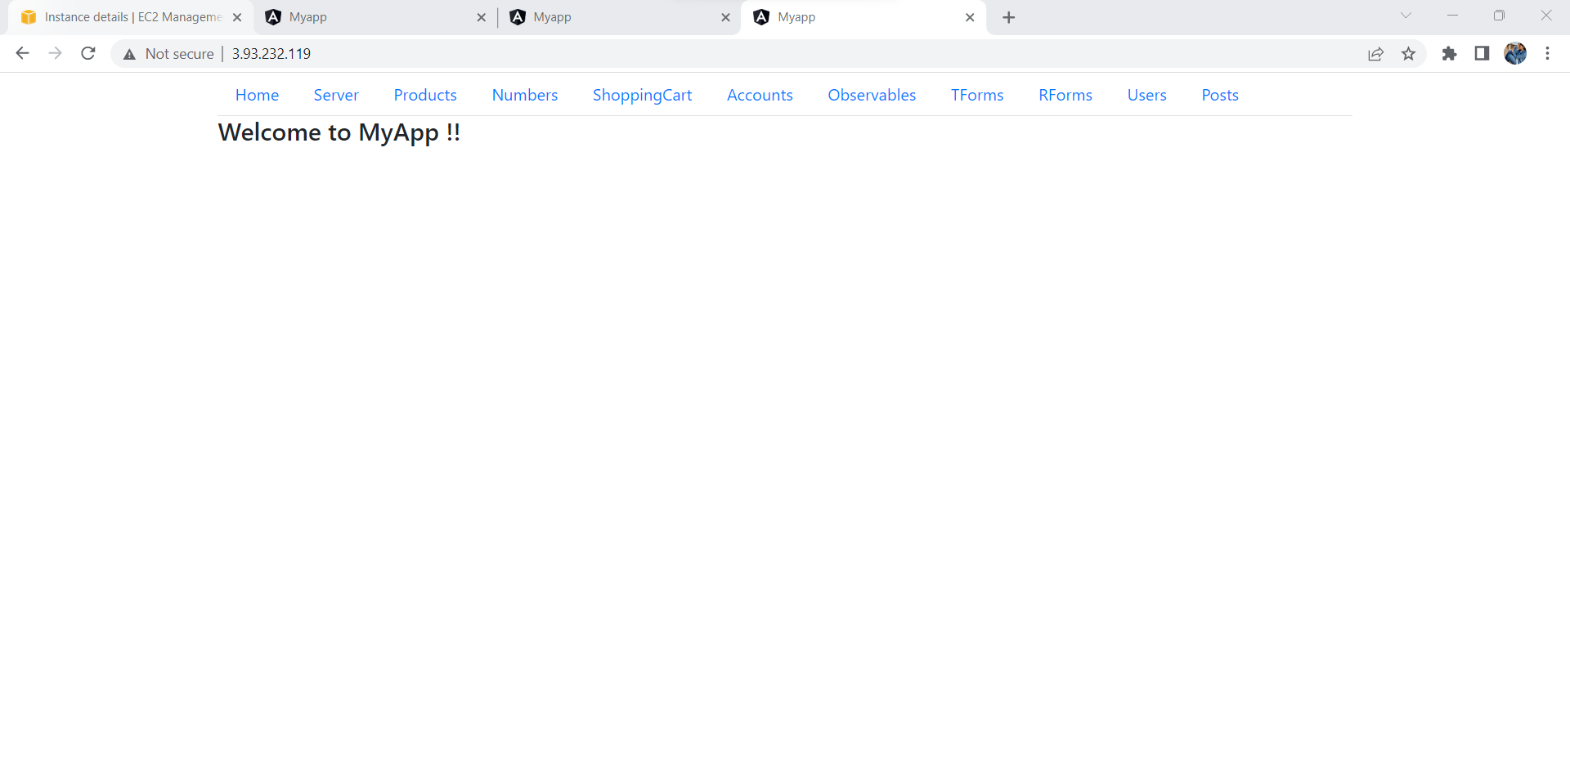

Output is shown where ip address of master is shown

